TWITTER SAMPLES

THANK YOU for making a difference in the fight against cancer at the University of Wisconsin! Whether you are walking, running or biking, The Ride provides an exhilarating day of fun and meaning to those affected by cancer. However, THE RIDE IS MORE THAN JUST AN EVENT in September. It is a year-round campaign that is accelerating cancer research at the University of Wisconsin.

This document serves as a RESOURCE OF TWITTER POST TEMPLATES representing participants at all levels of fundraising ambition. Whether your primary goal is to maximize dollars raised for cancer research or simply share your involvement in raising awareness, we applaud your effort in accelerating the brightest cancer minds, ideas and technologies at the University of Wisconsin.

Would you like to help others by submitting a sample to be included in this document? Please send samples and fundraising best practices to hello@TheRideUW.org.

STEPS TO SUCCESS
The MOST IMPORTANT ROLE you have in contributing to the UW cancer mission is to share your Ride journey.
Take a moment and determine your WHY and your level of AMBITION to accelerate our critical lifesaving efforts being developed today at the UW Carbone Cancer Center.
WHY are you walking, running or biking at The Ride?
What is your AMBITION in sharing your motivation with others? Are you looking to drive fundraising dollars to the cancer mission or simply share your involvement at The Ride?

A Benefit for Cancer Research at the University of Wisconsin
RAISED HERE. STAYS HERE.
TheRideUW.org

TABLE OF CONTENTS
The goal of this document is to provide a fluid resource for participants in utilizing and contributing email templates that share participants’ involvement and provide contribution opportunities.

MESSAGING OPPORTUNITY: AT THE TIME OF REGISTRATION
SAMPLE 1 FUNDRAISING ASK #1……….……………………………………..pp 3
SAMPLE 2 FUNDRAISING ASK #2…….………………………………………..pp 3
SAMPLE 3 JOIN MY FUNDRAISING TEAM #1…….………………...……..…..pp 4
SAMPLE 4 JOIN MY CORPORATE TEAM #1…….…………...……...……..…..pp 4
MESSAGING OPPORTUNITY: INVITE OTHERS
SAMPLE 1 JOIN ME AT THE RIDE #1…….……………………...……………..pp 5
SAMPLE 2 JOIN ME AT THE RIDE #2…….……………………...……………..pp 5

MESSAGING OPPORTUNITY: BIRTHDAY GIFT DONATION
COMING SOON!

MESSAGING OPPORTUNITY: MIDWAY THROUGHOUT CAMPAIGN
COMING SOON!

MESSAGING OPPORTUNITY: POST-EVENT
COMING IN AUGUST!

MESSAGING OPPORTUNITY: ANNUAL CAMPAIGN RESULTS
COMING IN OCTOBER!

AT THE TIME OF REGISTRATION, SAMPLE 1
FUNDRAISING ASK #1
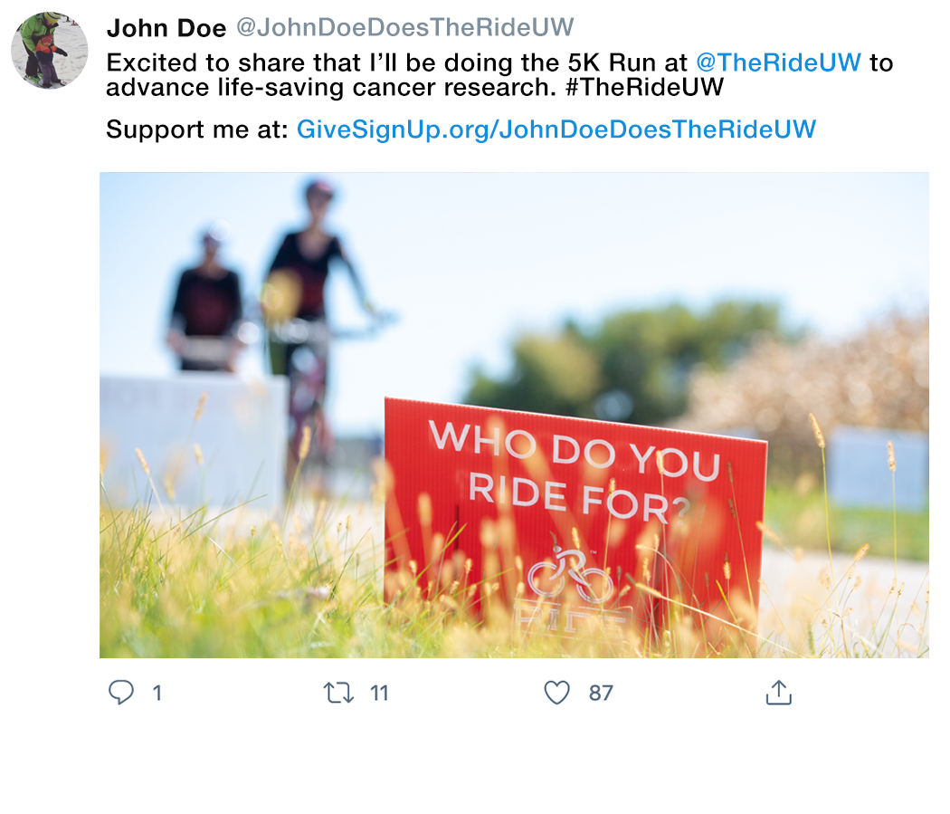
Excited to share that I’ll be doing the [5K, HALF-MARATHON, 25K, 50K, 100K, 100-MILE] [WALK, RUN, BIKE] route at @TheRideUW to advance life-saving cancer research. #TheRideUW

Support me at:
[PERSONAL FUNDRAISING PAGE URL]

[ADD PERSONAL IMAGE]

AT THE TIME OF REGISTRATION, SAMPLE 2
FUNDRAISING ASK #2
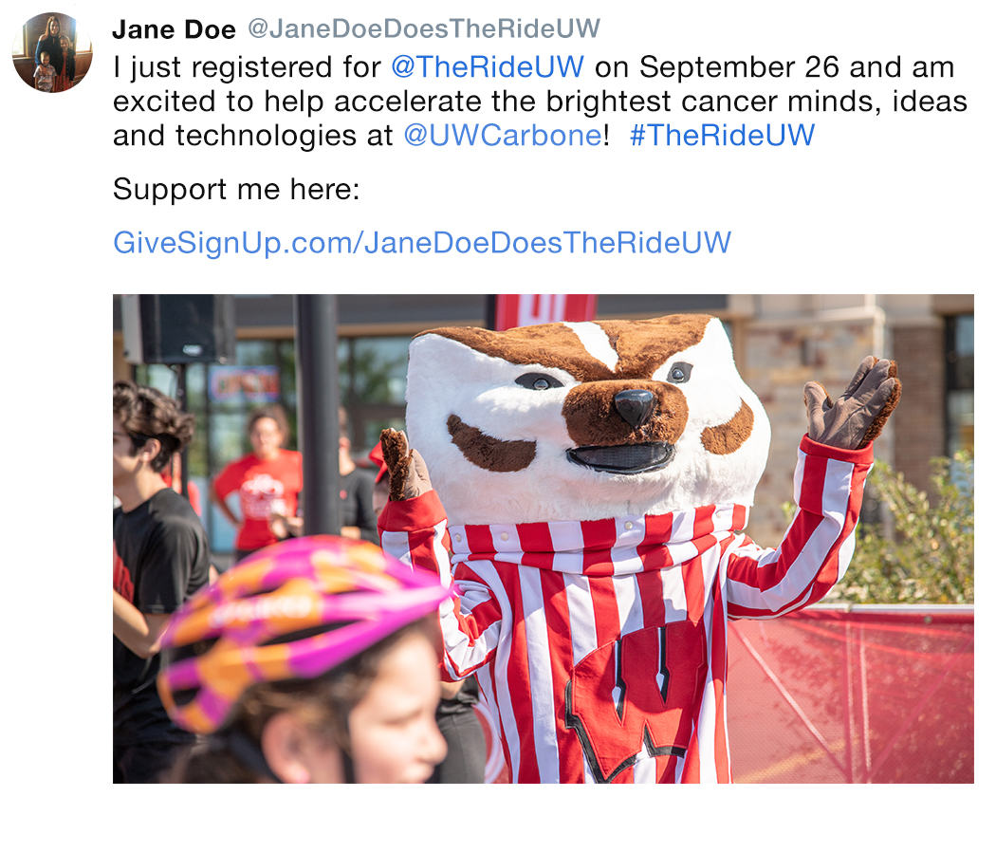
I just registered for @TheRideUW on September 26 and am excited to help accelerate the brightest cancer minds, ideas and technologies at @UWCarbone! #TheRideUW

Support me here:
[PERSONAL FUNDRAISING PAGE URL]

[ADD PERSONAL IMAGE]

AT THE TIME OF REGISTRATION, SAMPLE 3
JOIN MY FUNDRAISING TEAM #1
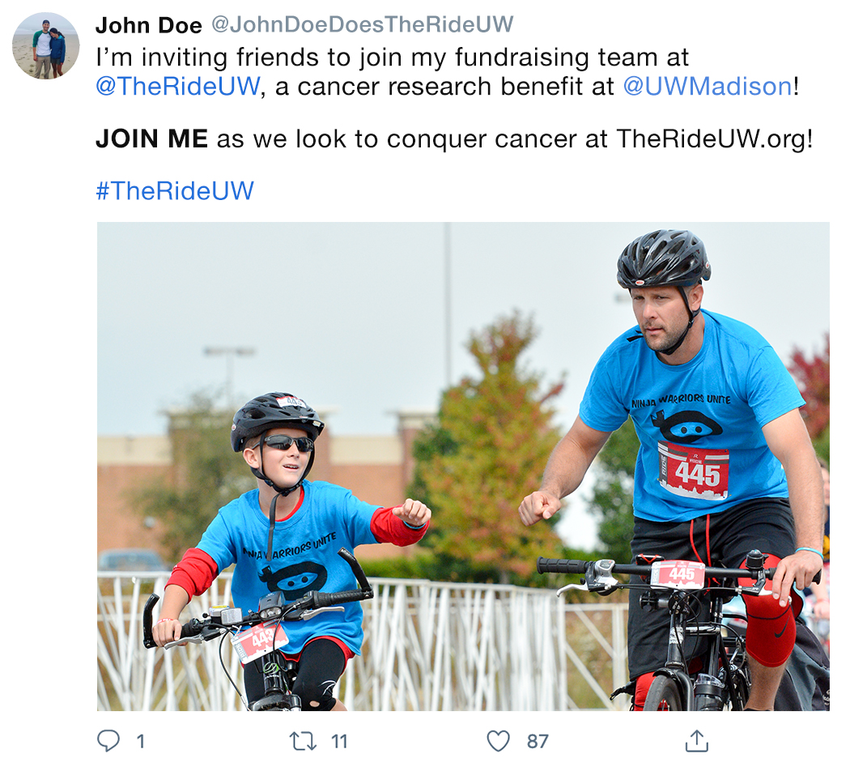
I’m inviting friends to join my fundraising team at @TheRideUW, a cancer research benefit at @UWMadison!

JOIN ME as we look to conquer cancer at TheRideUW.org!

#TheRideUW

AT THE TIME OF REGISTRATION, SAMPLE 4
JOIN MY CORPORATE TEAM #1
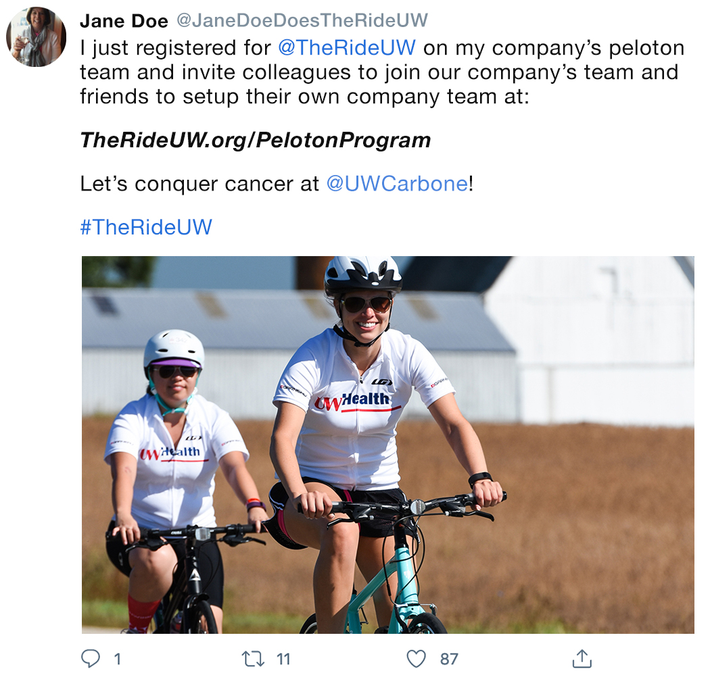
I just registered for @TheRideUW on my company’s peloton team and invite colleagues to join our company’s team and friends to setup their own company team at

TheRideUW.org/PelotonProgram

Let’s conquer cancer at @UWCarbone!

#TheRideUW

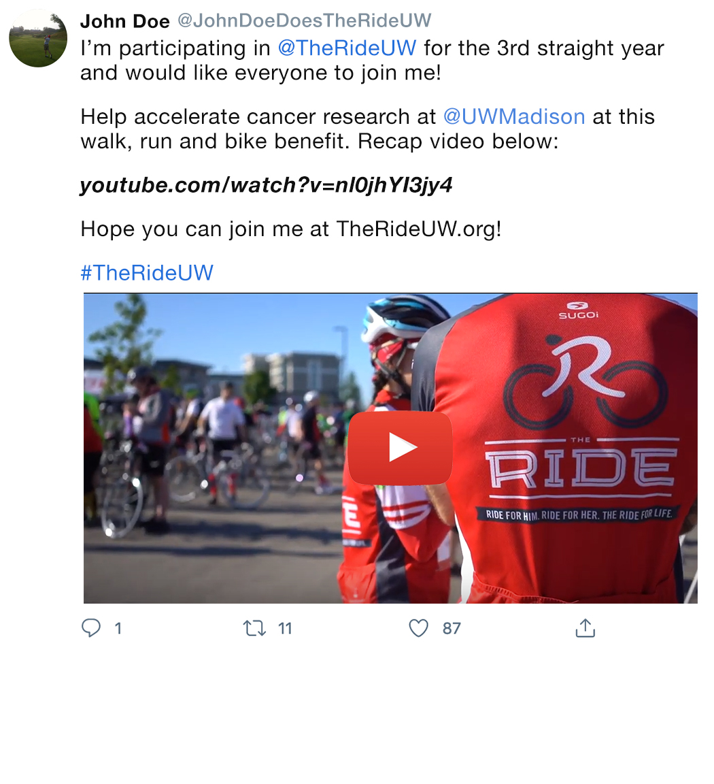
INVITE OTHERS, SAMPLE 1
JOIN ME AT THE RIDE #1

I’m participating in @TheRideUW for the [FIRST TIME? FOURTH STRAIGHT YEAR?] and would like everyone to join me!

Help accelerate cancer research at @UWMadison at this walk, run and bike benefit. Recap video below.

https://www.youtube.com/watch?v=nl0jhYI3jy4

Hope you can join me at TheRideUW.org!

#TheRideUW

INVITE OTHERS, SAMPLE 2
JOIN ME AT THE RIDE #2
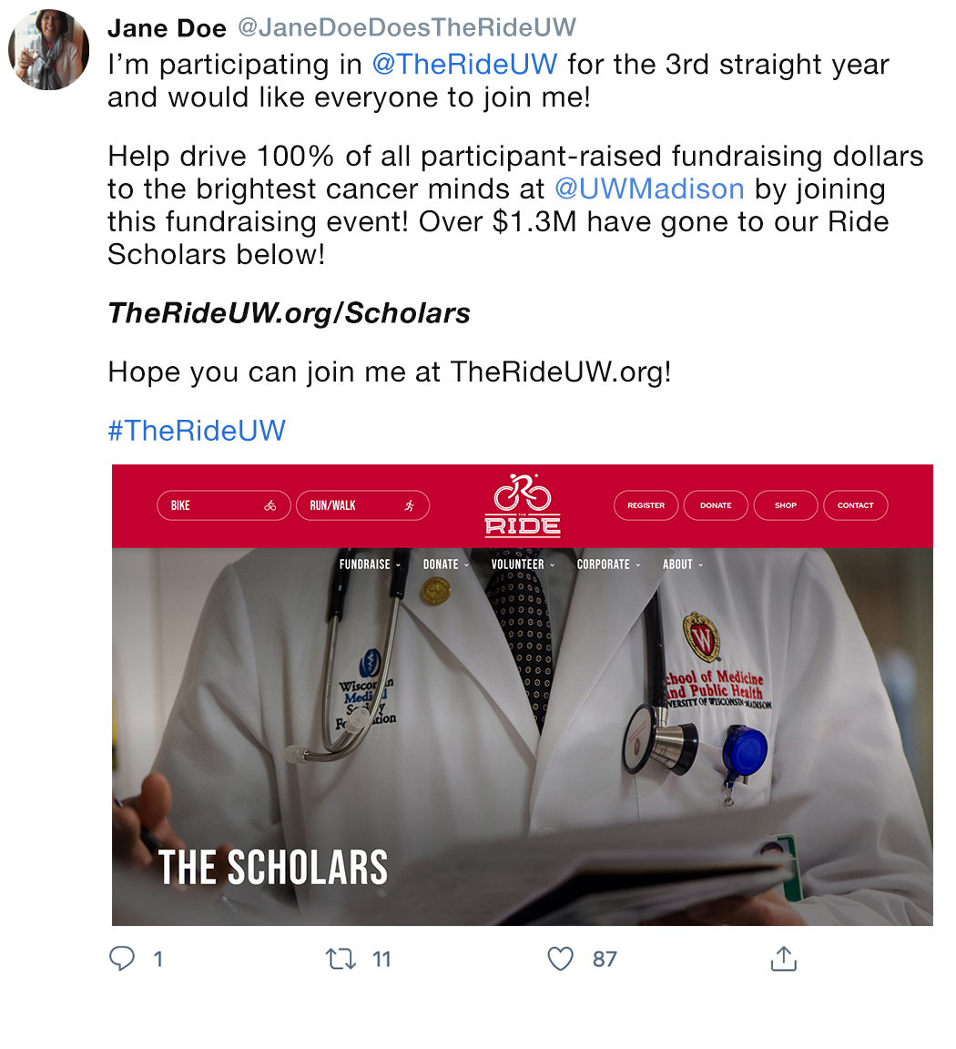
I’m participating in @TheRideUW for the [FIRST TIME? FOURTH STRAIGHT YEAR?] and would like everyone to join me!

Help drive 100% of all participant-raised fundraising dollars to the brightest cancer minds at @UWMadison by joining this fundraising event! Over $1.3M have gone to our Ride Scholars below!

TheRideUW.org/Scholars

Hope you can join me at TheRideUW.org!

#TheRideUW

